**4-2 Assignment: Wiring an LED Display**

Chris Bridges

Southern New Hampshire University

CS 350: Emerging Sys Arch & Tech

Professor Bryant Moscon

21 July 2025

Had a bit of fun. Modified to add my name.

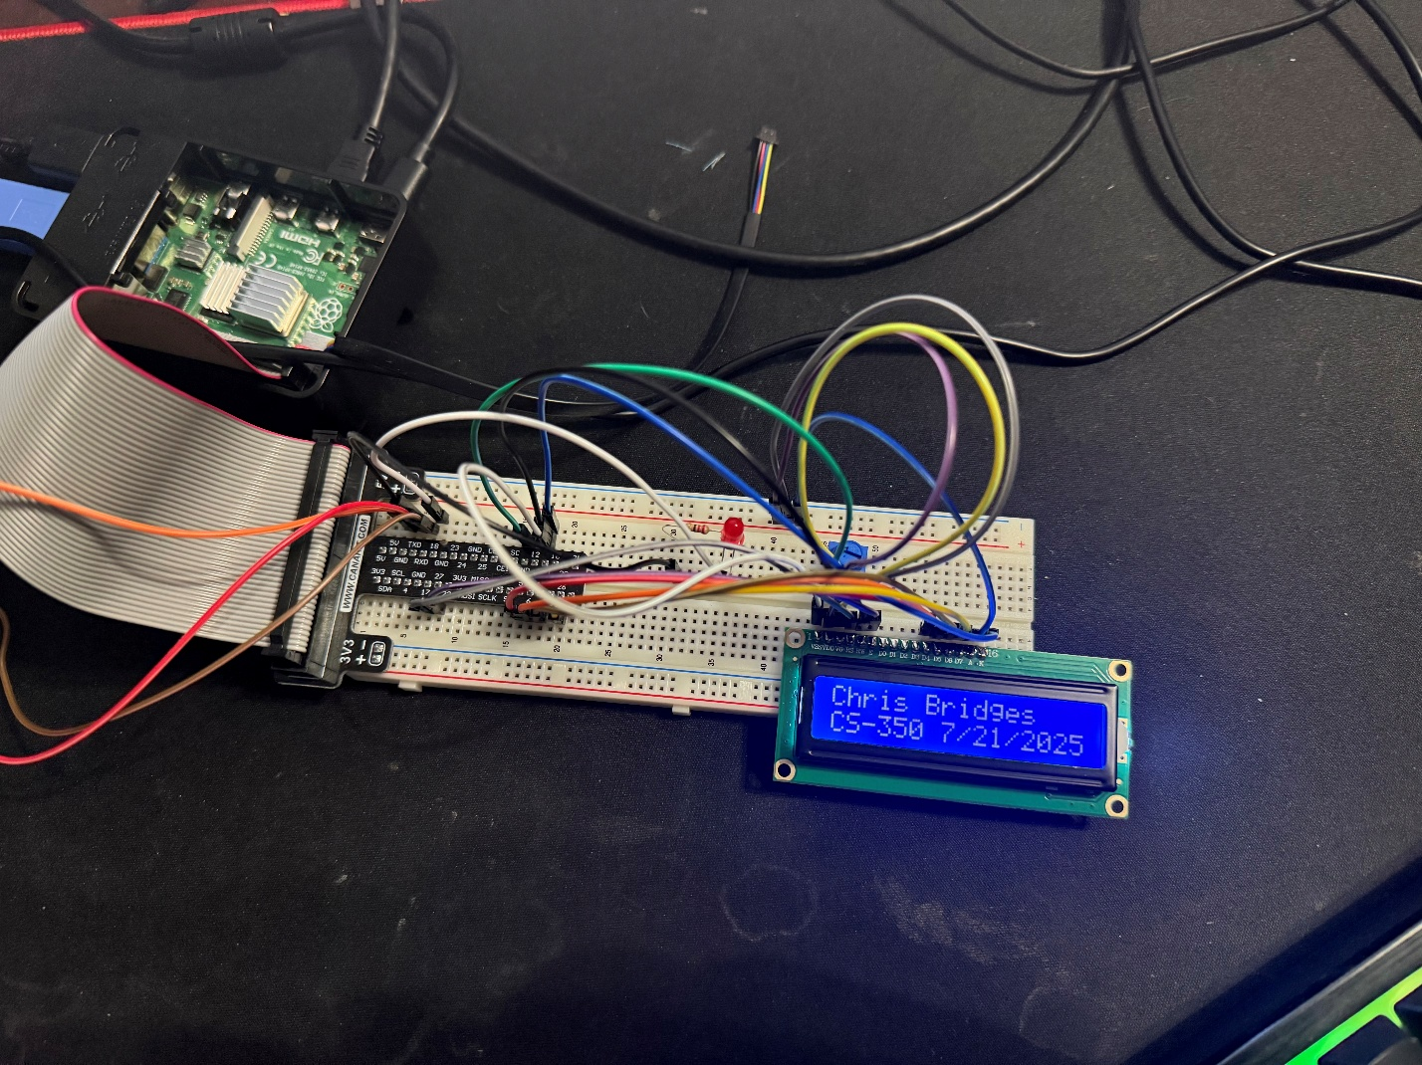

1. Why do you have a sleep command in your loop?
   1. If the LED display is used as a clock, it would refresh the time every second instead of many times per second.
2. What is the purpose of having a text display on an embedded device?
   1. Embedded devices use displays to provide feedback to users. Some machinery includes displays like this with error codes or instructions for its operators. Using a text display allows the embedded system to relay information to the user without the need for a computer.
3. How can you think of the display device as something that could relate to a state machine?
   1. A text display could be added to provide instructions for the user. It can provide the user with the machine’s current state and when to proceed with the next step. The display could also be used to inform the user of errors.

**Reflection**

This Assignment went much smoother than the last one. All my components worked properly, and setup went very smoothly. In previous assignments, I noticed the breadboard I received is different from the one in the instructions. The T-shaped breakout board does not physically fit where it does in the assignment instructions, since the +&- bus bars are arranged differently. Previously, I adjusted “Column E, Row 57” to “Column E, Row 58” to compensate. On this assignment, the corresponding pin was mentioned, so I could go from “LCD (D7) to (GPIO 26)” much easier.

As far as the process, I followed the instructions to install the Python packages, installed the components on the breadboard, and placed the jumper wires using the corresponding pins rather than board coordinates. Both the breakout board and the LCD screen are labeled so it was a quick and painless process. I studied the Python program, ran it to verify functionality, and then modified it to include my name.